Algebra 2 Name:____________________
Mr. Buescher
Equations of Parabolas
Section 6.3

Go to the course web site, go to “Spreadsheets”, download and open the spreadsheet “Parabolas, Vertex Form” on your floppy disk. When Excel asks, choose “Enable Macros” or “Yes”.
On the first page, you have a parabola. There are scroll bars to the left, right, and below the graph that move the parabola. Experiment a bit with moving the parabola and see how the equation changes. If you hold your cursor over the blue dots, it gives you the coordinates of that point. Now,
- Press “Reset” and move the parabola two units up and five units to the right. Record the equation of the parabola. Then simplify the equation as much as possible and solve for y (This example is worked for you).
Equation: (y – 2.0) = 1.0(x – 5.0)²
Simplified: y – 2 = (x – 5)² Solved for y: y = (x – 5)² + 2

- Move the parabola so its vertex is (0, 5). Then simplify the equation as much as possible and solve for y.
Equation: _______________________________
Simplified: _________________ Solved for y: _________________

- Move the parabola so its vertex is (-5, 0) and it opens down. Then simplify the equation as much as possible and solve for y. Do not expand the (x – h)² term.
Equation: _______________________________
Simplified: _________________ Solved for y: _________________

- Find equations for each of these parabolas:
Description | Equation | Simplified | Solved for y
Vertex (0, 8), opens down.
Vertex (-3, 0), opens up, as narrow as possible.
Vertex (0, 0), opens down, as wide as possible.
Vertex (3, 4), opens up, a little wider than the default.
Vertex (-2, 5), opens down.

- Describe what each of a, h, and k do in the equation (y – k) = a(x – h)².

Move to the “Parameters” page by clicking the tab on the bottom of the spreadsheet.
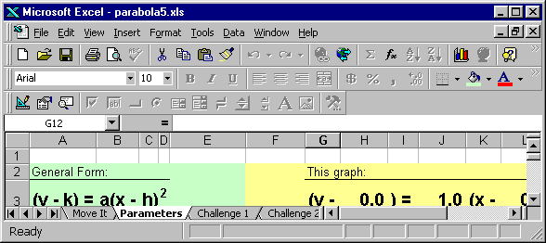
On this page, you can change the parameters and see how the graph changes. Experiment a bit with changing the parameters and see how the graph changes.

- Press “Reset” and record the parameters of the parabola. (This example is worked for you).

a = 0.0 h = 0.0 k = 0.0 Equation: (y – 0.0) = 1.0(x – 0.0)²

7. Find a set of parameters that will give you a parabola with vertex (5, -5), opening up.

a = ______ h = ______ k = ______ Equation: __________________________

- Find a set of parameters that will give you a parabola with vertex (-3, 4), opening down, as narrow as possible.

a = ______ h = ______ k = ______ Equation: __________________________

- Set the following parameters and find the given information:

Parameters | Vertex | Opens Up or Down? | Narrow or Wide?
(y – 4) = 2(x – 3)²
(y – -4) = 2(x – -3)²
(y – 4) = -2(x – 3)²
(y + 4) = 0.2(x + 3)²
(y – 4) = -0.2(x + 3)²

- Describe the graph of the parabola (y – k) = a(x – h)². What is the vertex? Does it open up or down? How wide is it?

And now … on to The Challenge!

Switch to the “Challenge 1” page.

On this page, the computer chooses the parameters of a quadratic equation in vertex form. Your task is to move the red parabola so that it matches the equation.

Remember that the left-hand scroll bar moves the parabola up and down, the bottom scroll bar moves it side to side, and the right-hand scroll bar changes the shape of the parabola.

There are a number of problems, starting with easier ones and getting progressively more difficult. Try it out! If you don’t match it the first time, keep changing it until you get it right.

And now, the Even Bigger Challenge!

Switch to the “Challenge 2” page.

This time, the computer draws a parabola in red. Your task is to enter the coordinates that would generate that parabola.

Type the parameters in for a, h, and k under “Your Equation.” Then press "Check Answer" to see how well you did!

Hint: The translations (h and k) are all integers. The constant a is either an integer or a multiple of 0.2

There are a number of problems, starting with easier ones and getting progressively more difficult. Try it out! If you don’t match it the first time, keep changing it until you get it right.

Congratulations!
You’re now an expert at applying the Graph Translation theorem to parabolas.
Give yourself a pat on the back.

